Estimating number of Bugs by least squares.

N bugs , p probability of discovering a bug

N |  | Data | N*p | (Data-N*p)^2
115 | 0 - 10 | 4 | 5.40534 | 1.974981856
111 | 10-20 | 2 | 5.217329 | 10.35120354
109 | 20-30 | 8 | 5.123323 | 8.275272215
101 | 30-40 | 6 | 4.747299 | 1.569259727
95 | 40-50 | 4 | 4.465281 | 0.216486654
91 | 50-60 | 6 | 4.277269 | 2.967800649
85 | 60-70 | 6 | 3.995252 | 4.01901592
79 | 70-80 | 3 | 3.713234 | 0.508702586
76 | 80-90 | 3 | 3.572225 | 0.327441463
73 | 90-100 | 2 | 3.431216 | 2.048379607
 |  |  |  | 32.25854422
 |  | n | p
 |  | 115 | 0.047003

For each N compute “best” p – one that minimises sum of squares

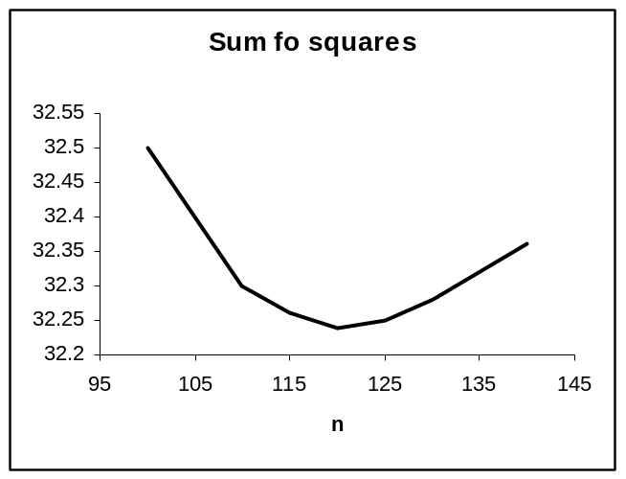

“best” value of N at about 120 (in steps of 5) p=0.0447

So we get an estimate.

